Module 11 CCNA -Automation and Programmability

How Automation Impacts Network Management:

Automation and Network Management: A Paradigm Shift

Network management has evolved significantly with the advent of automation. Here’s how automation impacts network management:

Efficiency and Speed:

Automation reduces manual intervention, allowing network administrators to perform tasks more quickly and accurately.

Routine tasks (e.g., configuration changes, updates, backups) can be automated, freeing up time for strategic planning and troubleshooting.

Consistency:

Automation ensures consistent configurations across devices.

It eliminates human errors caused by manual configuration.

Scalability:

As networks grow, managing them manually becomes impractical.

Automation enables seamless scaling by applying consistent policies to new devices.

Self-Healing:

Automated monitoring detects issues (e.g., link failures, performance degradation).

Remediation actions (e.g., failover, rerouting) can be triggered automatically.

Compliance and Security:

Automation enforces security policies consistently.

It ensures compliance with industry standards (e.g., PCI DSS, HIPAA).

DevOps Integration:

Automation bridges the gap between network operations (NetOps) and development (DevOps).

It aligns network changes with application deployments.

In summary, automation streamlines network management, enhances reliability, and accelerates innovation.

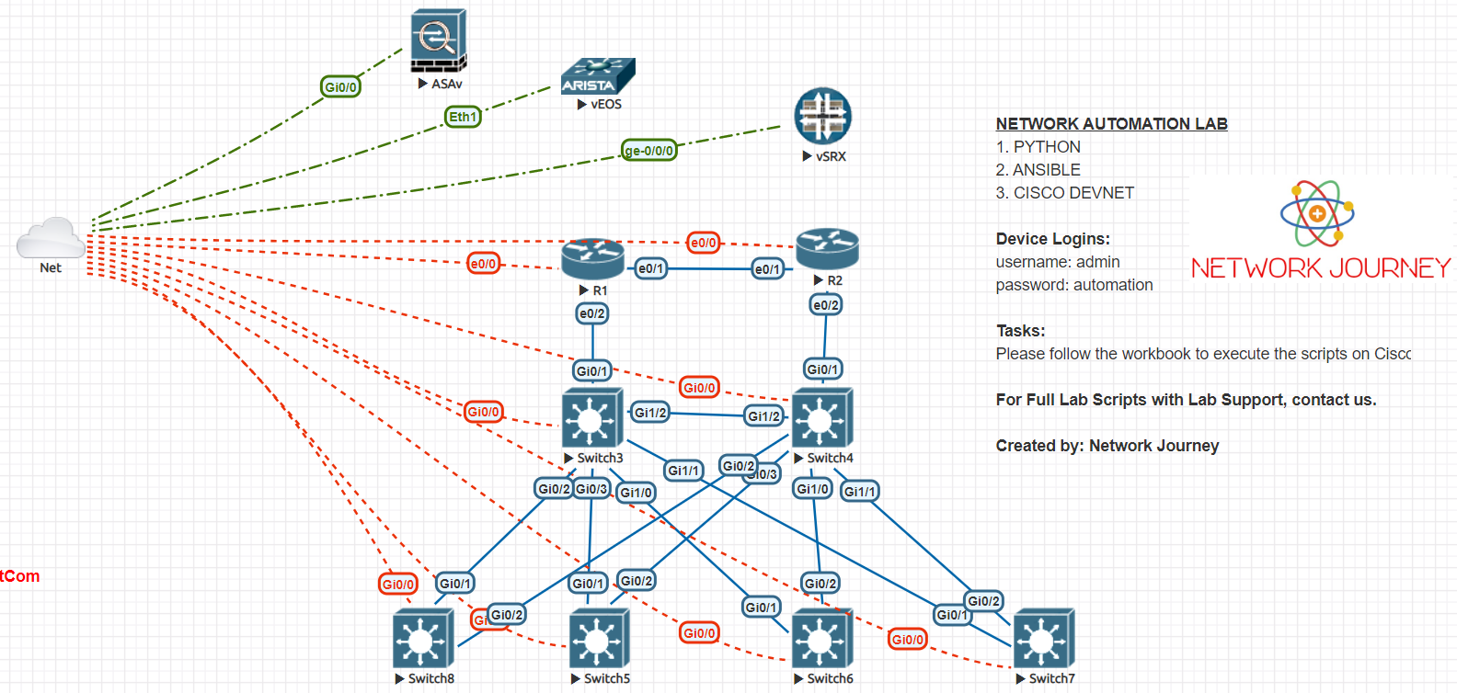

Comparing Traditional Network with Controller-Based Networking:

Traditional Network:

Manual configuration: Each device configured individually.

Decentralized control: Devices operate independently.

Limited visibility: Monitoring tools provide fragmented insights.

Scalability challenges: Manual scaling is time-consuming.

Reactive troubleshooting: Manual diagnosis and resolution.

Controller-Based Networking:

Centralized control: A controller (e.g., SDN controller) manages network devices.

Programmatic configuration: Policies defined centrally and pushed to devices.

Enhanced visibility: Real-time monitoring and analytics.

Scalability: Easily add new devices without manual configuration.

Proactive troubleshooting: Automated detection and response.

In summary, controller-based networking offers agility, scalability, and better control.

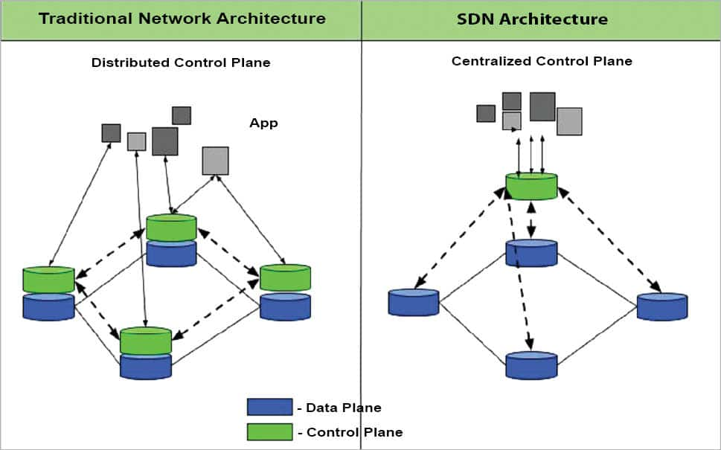

Explaining Virtualization:

What is Virtualization?

Virtualization abstracts physical resources (e.g., servers, storage, networks) into virtual instances.

It allows multiple virtual machines (VMs) or containers to run on a single physical host.

Types of Virtualization:

Server Virtualization:

Run multiple OS instances (VMs) on a single physical server.

Hypervisors (e.g., VMware, Hyper-V) manage VMs.

Network Virtualization:

Abstract network components (e.g., switches, routers) into virtual entities.

SDN (Software-Defined Networking) controllers manage network policies.

Storage Virtualization:

Pool storage resources and present them as virtual volumes.

Improves storage utilization and flexibility.

Desktop Virtualization:

Run multiple desktop OS instances on a single physical machine.

VDI (Virtual Desktop Infrastructure) provides centralized management.

Benefits of Virtualization:

Resource Efficiency: Optimal utilization of hardware resources.

Isolation: VMs are isolated from each other.

Flexibility: Easily move VMs between hosts.

Disaster Recovery: VM snapshots enable quick recovery.

Cost Savings: Fewer physical servers needed.

In summary, virtualization revolutionizes resource management, agility, and cost-effectiveness.

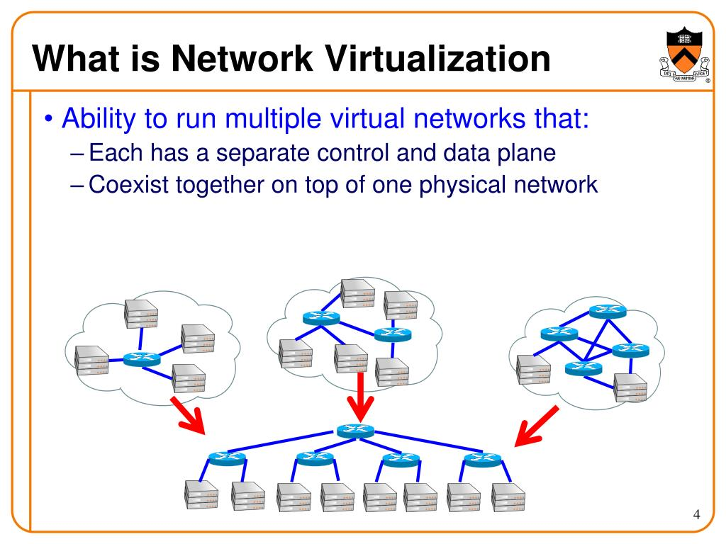

Describe Characteristics of REST-based API

Client-Server Architecture:

A RESTful API follows a client-server architecture. Here’s what it means:

Client: Any device or application (like a web browser or mobile app) that can make HTTP requests.

Server: The application providing the API, which responds to client requests.

Why It Matters:

Separation of concerns: Developers can focus on client-side and server-side independently.

Scalability: Each component can scale without affecting the other.

Statelessness:

REST APIs are stateless. What does that mean?

No Client Context: Each request from the client to the server must contain all necessary information. The server doesn’t store any client state.

Why It Matters:

Simplicity: Stateless design simplifies communication.

Scalability: Stateless servers handle more clients efficiently.

Clear Statement of Cacheability:

REST APIs explicitly indicate whether responses can be cached by clients or not.

Why It Matters:

Caching improves performance by reducing redundant requests.

Clear guidelines prevent unexpected caching behavior.

Uniform Interface:

REST APIs adhere to a uniform set of rules:

Resource-Based: Resources (e.g., data, objects) are identified by unique URLs (endpoints).

HTTP Verbs: Use standard HTTP methods (GET, POST, PUT, DELETE) for actions on resources.

Representation: Responses are in a consistent format (e.g., JSON, XML).

Why It Matters:

Predictability: Developers know how to interact with any REST API.

Interoperability: Clients and servers can communicate seamlessly.

Layered System:

REST allows for a layered architecture:

Client interacts with an intermediary layer: This layer could be a proxy, load balancer, or cache.

Intermediary interacts with the server: The client doesn’t need to know the server’s details.

Why It Matters:

Flexibility: Layers can be added or modified without affecting clients.

Security: Intermediaries can handle authentication, encryption, etc.

Resource-Based:

REST APIs treat everything as a resource (e.g., users, products, orders).

Each resource has a unique URL (endpoint) for interaction.

Why It Matters:

Consistency: Uniform handling of different resource types.

Simplicity: One approach for all resources.

Methods of Automation:

There are several methods of automation in the context of IT and network management:

Scripting:

Writing scripts (e.g., Python, Bash) to automate repetitive tasks.

Useful for configuration changes, backups, and monitoring.

Example: Automating router configuration updates using Python scripts.

Configuration Management Tools:

Tools like Ansible, Puppet, and Chef manage configurations across devices.

Declarative approach: Define desired state, and the tool ensures compliance.

Example: Ansible playbooks to configure network devices uniformly.

Orchestration:

Coordinating multiple tasks or processes to achieve a desired outcome.

Often used in complex workflows (e.g., provisioning a new service).

Example: Orchestrating VM deployment, network setup, and security rules.

Network Automation Platforms:

Platforms designed specifically for network automation.

Cisco DNA Center, Juniper Junos Space, Arista CloudVision, etc.

Example: Using Cisco DNA Center to automate network provisioning.

Event-Driven Automation:

Triggering actions based on specific events (e.g., alarms, thresholds).

Event-driven scripts or tools respond to real-time events.

Example: Automatically scaling resources when traffic exceeds a threshold.

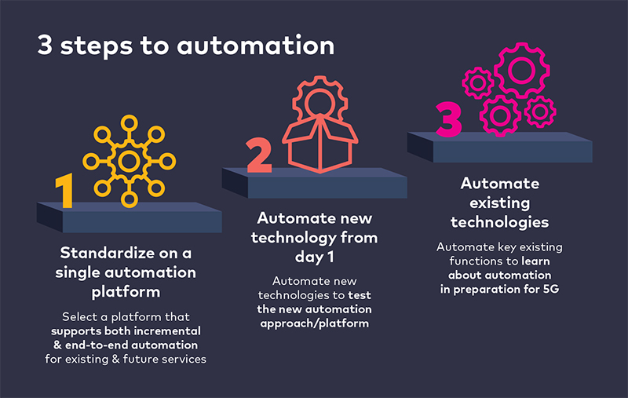

Software-Defined Networking (SDN):

SDN is an architectural approach that separates the control plane from the data plane in networking:

Control Plane:

Centralized controller (software) manages network policies.

Decides how data packets should be forwarded.

Example: OpenFlow controller in SDN.

Data Plane:

Network devices (switches, routers) forward data packets.

No intelligence; follows controller instructions.

Example: SDN-enabled switches.

Advantages of SDN:

Simplified management: Centralized control.

Programmability: Dynamic policy enforcement.

Agility: Rapid network changes.

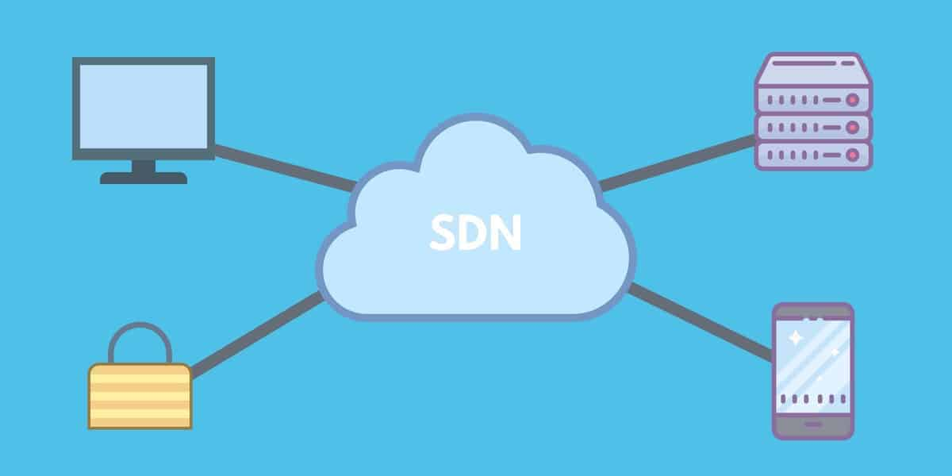

Cisco DNA Center:

Cisco DNA Center is a network management platform for intent-based networking:

Features:

Automation: Simplifies network provisioning, configuration, and monitoring.

Assurance: Provides real-time insights and analytics.

Security: Enforces policies and detects threats.

SD-Access: Automates network segmentation.

Components:

Controller: Centralized management.

Assurance Engine: Monitors network health.

Design and Policy: Defines network intent.

Provisioning: Automates device setup.

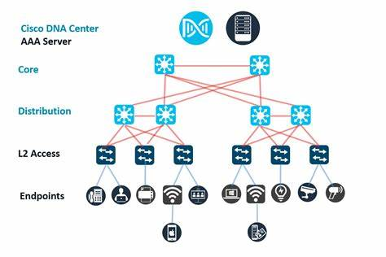

SD-Access and SD-WAN:

SD-Access (Software-Defined Access):

Purpose: Automates campus network segmentation.

Components:

Fabric: Underlay and overlay network.

Identity Services Engine (ISE): Authenticates users and devices.

DNA Center: Orchestrates policies.

Benefits: Simplified segmentation, improved security.

SD-WAN (Software-Defined Wide Area Network):

Purpose: Optimizes WAN connectivity (branch offices, remote sites).

Features:

Path Selection: Dynamically chooses best path (MPLS, Internet, 4G).

Application-Aware Routing: Prioritizes critical apps.

Centralized Management: Orchestrates edge devices.

Benefits: Cost savings, better performance.

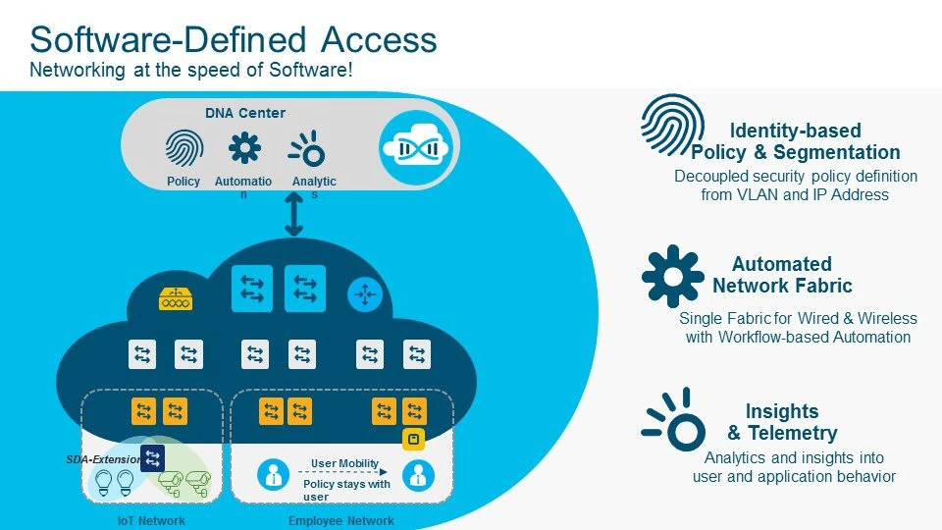

SD-ACESS

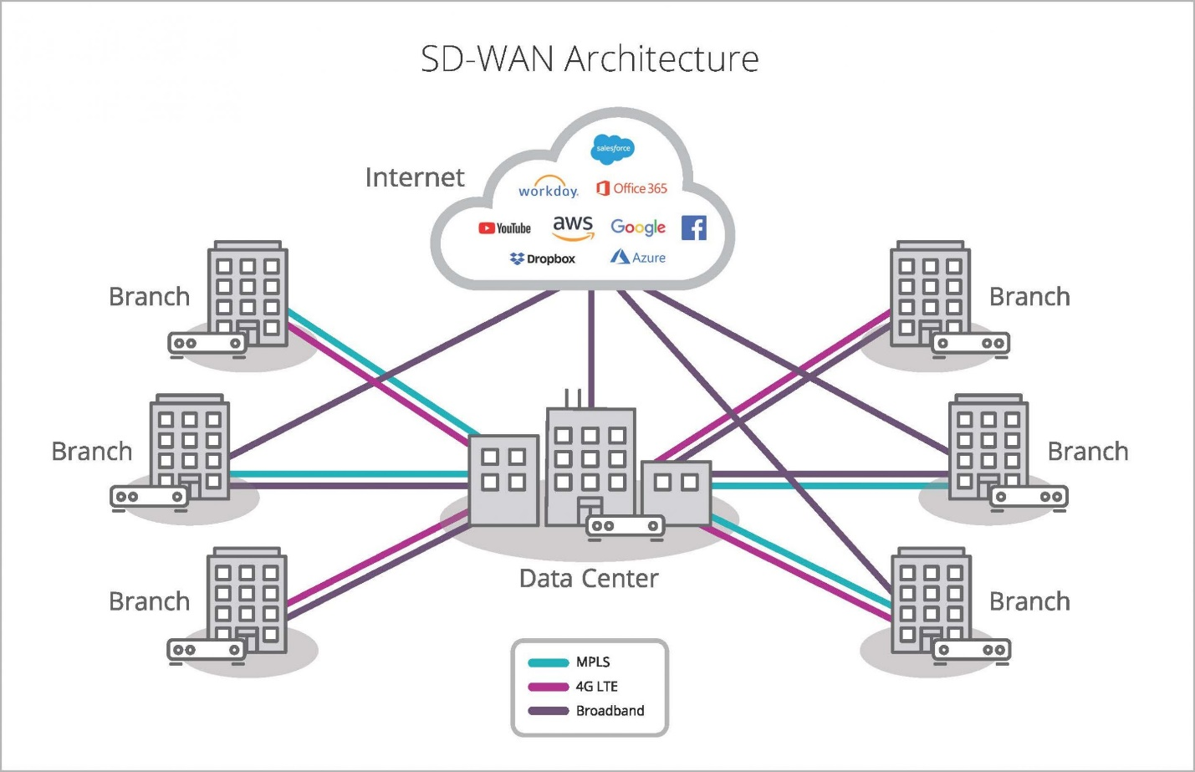

SD-WAN